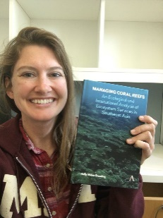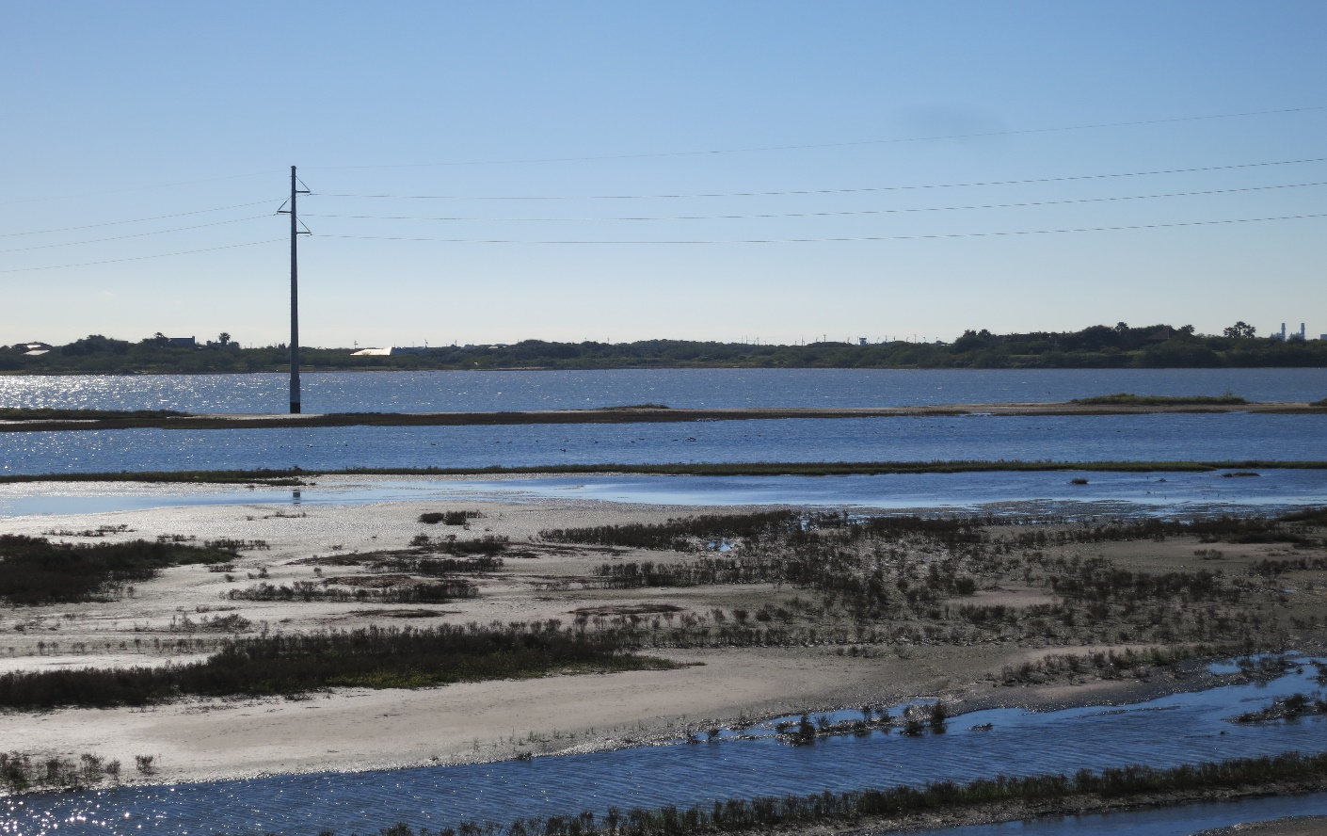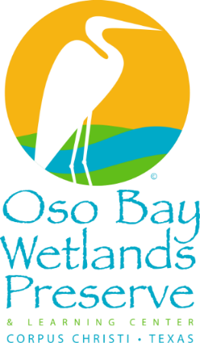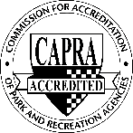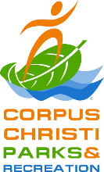

The City of Corpus Christi promotes participation regardless of race, color, national origin, sex, age, religion, disability or political belief. Reasonable accommodations are provided upon request and in accordance with the Americans with Disabilities Act. For assistance or to request a reasonable accommodation, please call 361-826-3460 at least 48 hours in advance. Upon request, this information can be available in large print or digital file.

OsoBayWetlandsPreserveAndLearningCenter

**Dr. Kelly Dunning** – Coastal Training Program Coordinator

This presentation will cover who owns what land on the South Texas coast, and what policy, laws, and actors are involved in protecting, managing, and developing the coast. People may see a new condo or parking lot go up over night and wonder, "who owns that land?" That is often a complex question with an equally complex answer that tends to vary state by state and involves federal, state, local, and private actors. Dr. Kelly Dunning, a research scientist at the University of Texas Austin Marine Science Institute will help answer these questions and more in the South Texas context. Dr. Dunning holds a PhD in natural resource management from MIT, and specializes in issues of resource management policy. She runs the Coastal Training Program of the Mission Aransas National Estuarine Research Reserve which exists to translate scientific topics to policy-makers to aid in resource management decision-making

* Class size limited to 24 participants.
* This program is FREE and open to individuals and families.
* Walk-ins are welcome on a first come first served basis.
* This program is for individuals and families with children ages 12 and older.
* To reserve a space, please register at <http://register.ccparkandrec.com>.

For more information, contact Caleb Harris at (361) 826-3947 or [calebh@cctexas.com](mailto:calebh@cctexas.com).

Meet at the Oso Bay Wetlands Preserve & Learning Center located at

**2446 N. Oso Parkway, Corpus Christi, TX 78414**

osopreserve.com

Eco-Expert

April 18, 2019

6pm–7pm

*Who manages that land?*

For Adults